HOW TO ACCESS POWERSAFE TRAINING
STEP 1:
Go to www.powersafetraining.org

STEP 2: Click on Login To Training (Students). If you do not see this on your screen, see below.
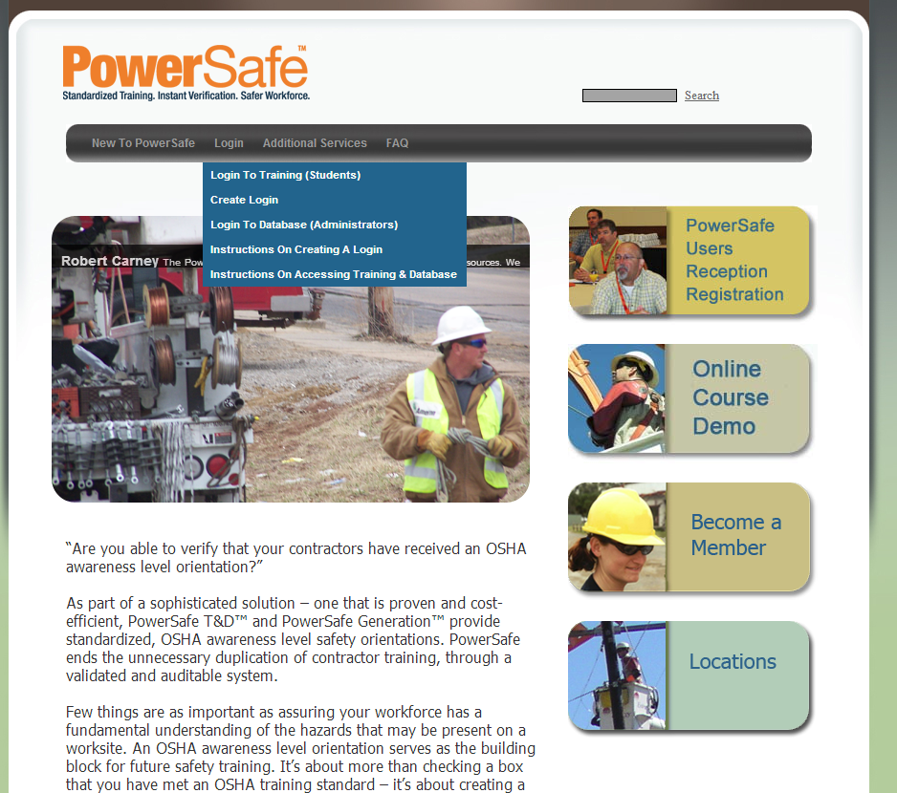
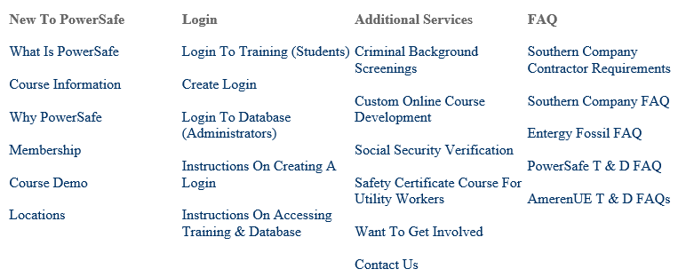

STEP 3: Click on click here
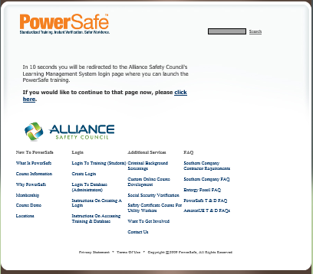

STEP 4: Enter your social security #. Enter the username and password provided to you from your company administrator or supervisor. If you do not have invoicing privileges a credit card must be used.
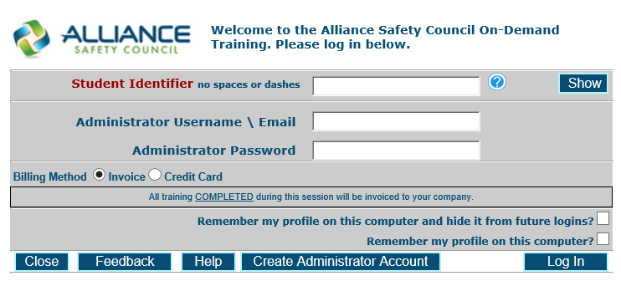

You may see the screen below, if the information is correct in the fields, Click here.
If you are not already in our system, you will be asked to re-enter your SSN, First and Last name.
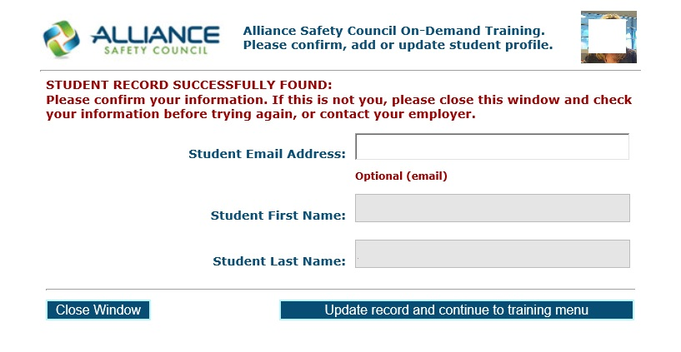

STEP 5: Click here

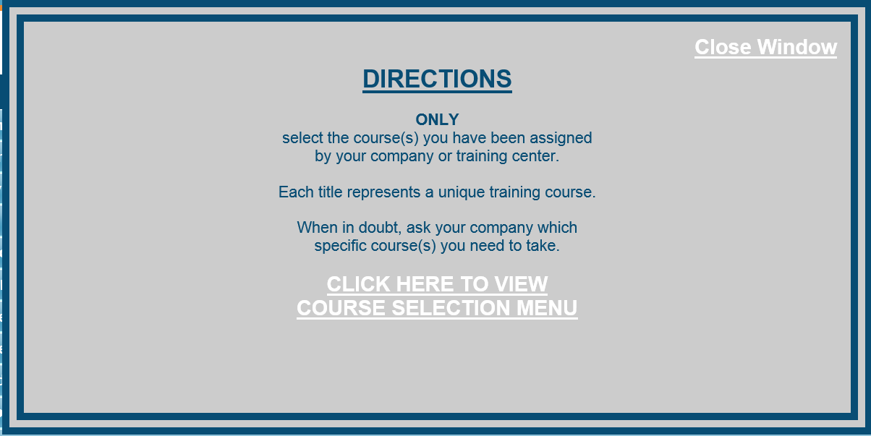

STEP 6: Scroll down to the PowerSafe courses and click on the Click to Start/Continue button of the course you would like to take.

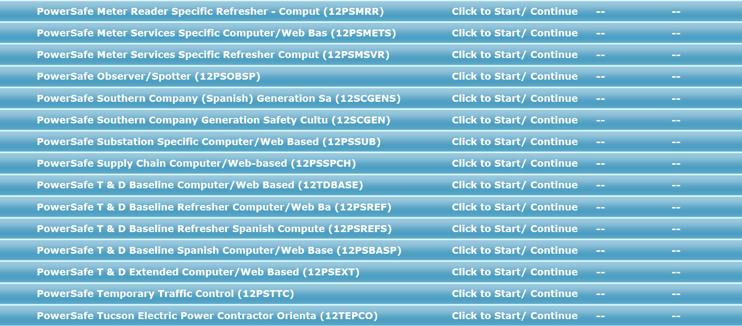

STEP 7: Click [HERE] to start the training.

STEP 8: Click START COURSE to begin training on your selected course.

